
SCOOBY’S MEDELLIN TRAVLERS GUIDE
IF ANYONE HAS BETTER UP TO DATE INFORMATION ON ADDRESSES, PRICES OR ANYTHING THEY THINK SHOULD BE PUT IN PLEASE DO NOT BE SHY PM ME AND I WILL INCLUDE YOUR INFO
NESTLED in the stunning Aburra Valley in the mountainous Antioquia terrain lies the magical city of MEDELLIN, COLOMBIA: "The Land of Eternal Spring" and "Capital of The Flowers". Medellin is experiencing an renaissance.
Medellin a proud and modern city of almost three (3) million population, with an area of 362 kilometers squared and an average temperature of 24 degrees Centigrade. It is capital of Antioquia department. It is widely regarded in Colombia as a clean, well-organized and economically vibrant community. Its people are hard-working and industrious. Major industries include coffee and flower export, information technology and hotel services. Medellin has more Internet hook-ups than any other Colombian city. It is also the fashion capital of Colombia. And each year the "Feria de Las Flores" (Flower Festival) attracts visitors from all over South America for parades and conventions. The city's fast and efficient "Metro" is the only public transit subway system in Colombia. And the "Empresas de Pública de Medellin" is widely viewed as the best public utility service in the country. In culinary delights, Medellin is said to have created Colombia's ubiquitous "arepa" - a bread and corn patty stuffed with cheese, and often chicken or beef. Meanwhile, Medellin's historical traditions are evident in Pueblito Viejo, a squared section of town with homes and shops preserved as they were 100 years ago.
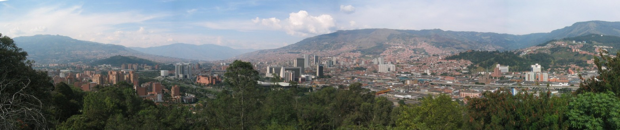
VIDEO’S OF MEDELLIN:
http://youtube.com/watch?v=6hWh4eCwt_Q&search=medellin
http://youtube.com/watch?v=IEFIrXXsyj0

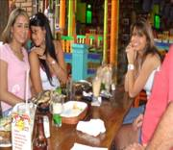

The Medellin Lady, affectionately called Paisa, is seen by many as the most beautiful of the Colombian Latinas. A famous Colombian saying goes: "If you want a pretty mistress, go to Cali, but if you want a beautiful wife, go to Medellin”.

INTERNATIONAL DIALING CODES
The country code is: 57
the city code is: 4
When calling a cell phone just use the country code not the city code.

TOURIST VISA
Passport and proof of onward/return ticket required for tourist stay of up to 180 days. Upon arrival the Colombian Immigration authority stamps a stay authorization, normally no longer than 90 days (extendible up to 180 days). Minors (under 18) who are
traveling alone, with one parent, or with a third party, must present a copy of their birth certificate and written authorization from the absent parent(s) or legal guardian, specifically granting permission to travel accordingly. This document must be notarized before a Colombian consular officer in the United States. Visa must be obtained before arrival for persons planning to do business, temporary work (consultant), and study. Student, tourist, and visitor visa fee not required for U.S citizens; authorization for stay is stamped upon arrival by Colombian Immigration Authority and free of charge. Likewise, student visa is also free for U.S. citizens. Work visa fee is $205. Processing time ranges from 48 hours to 2 weeks. For additional information,

American Citizens are required to only possess a U.S. Passport at the Colombian port or gate of entry to secure a Tourist Visa for thirty (30) days. Visitors from Australia, New Zealand, most European countries and the USA do not need visa if staying less than 90 days as a tourist. Other passport holders should check visa status with Colombian consular representation before departure
http://www.colombiaemb.org/opencms/opencms/consulates/visas.html
http://travel.state.gov/travel/tips/brochures/brochures_1229.html
AIRLINES
The following airlines service Medellin:
http://www.laguiahotelera.com/web/CompanyCategory.aspx?ica=5476&nca=Aerol%c3%adneas&ici=*&ipa=pcountry&idi=1&nci=*&ies=*&nes=Todos%20los%20Estados&ipg=1&k=62424&tbu=2&type=category&txb=AEROLINEAS++++
AVIANCA:
Calle 53, No. 45-112,
Tel (Int'l): 513-5050, Tel (Domestic): 5115100 . Avianca is the first commercial airline founded on the Américas and second on the world.
www.avianca.com
AMERICAN AIRLINES:
Cra. 43A, No. 34-95, Local 211,
Tel: 381-4546
http://www.aa.com
COPA AIRLINES:
Cra. 43A, No. 34-95, Local 211,
Tel: 381-7277
http://copaair.com

AEXPA:
http://www.aexpa.com/
AEROREPUBLICA:
www.aerorepublica.com.co
AIRES:
Reservations in Bogota: 294.0300
www.aires.aero
SANTENA:
PBX in Bogota: 423.8530
Reservations center: 01900 331.7100
www.satena.com
ADA-AEROLINEAS DE ANTIOQUIA:
Reservas 255 99 99 Medellín
Línea Gratuita Nacional 01 – 8000 41 2525
E mail: ada@geo.net.co
Oficinas:361 73 29
http://www.aerolineadeantioquia.com/

AEROPOSTAL:
http://www.aeropostal.com/aero2004/home.asp

TACA:
http://www.taca.com/index.asp#
AIRPORTS
JOSE CORDOBA INTERNATIONAL AIRPORT:
(International & Domestic)
In the near-by town of "Rionegro" serves Medellin.
Tel: 562-2828.

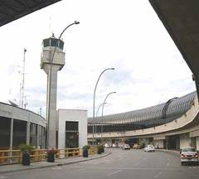
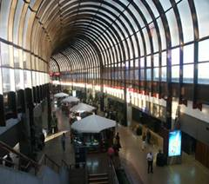
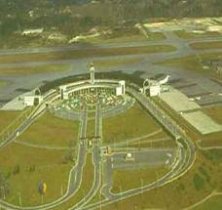

http://www.medellininfo.com/airlines/mde.html
Location: 30 km/19 miles S.E. of the city.
By Taxi:
One-Way Taxi Fare is about 30,000 Colombian Pesos U.S.$16.
It is a forty minute ride to the city on a very scenic, clean and well-lit roadway.
By Bus:
Frequent mini-buses run to the corner of Carrera 50A and Calle 53. U.S.$2. Trip takes about 45 minutes.
Airport Departure Tax is $28.00 USD (or equivalent in Pesos) without exemption, for stays up to 2 months
U.S.$46 for longer periods.(or equivalent in Pesos)with exemption.
Domestic Departure Tax U.S.$5. Payable in pesos or dollars.
Credit cards not accepted.
Medellin Airport, Colombia, Dep. Administrativo de Aeronautica Civil, Medellin.
Tel: +57 (09)4 601212
Fax: +57 (09)4 603804
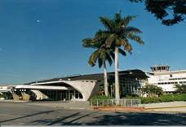
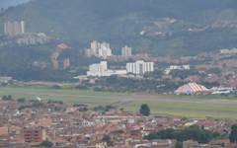

AEROPUERTO OLAYA HERRERRA: (Domestic)
http://www.aeropuertoolayaherrera.gov.co/ppal.php
The Olaya Herrera Domestic Airport is conveniently located in the center of Medellin, a couple of miles east of the POBLADO METRO STATION. From the station you can take a bus or taxi, direct to the airport. Hours of operation are during daylight, from 6 in the morning until 6 at night. The airport has good ground access. It's modern, clean and functional and has good security. All airline, travel and car rental companies are conveniently located on the main floor.
BUS COMPANYS
BOLIVARIANO:
http://www.bolivariano.com.co/
FLOTA MAGDALENA:
http://www.flotamagdalena.com/

EXPERSSO PALMIRANDA:
http://www.expresopalmira.com.co/

TURIBUS MEDELLIN:
Calle 9c Sur No.50ff-97
Medellin
Phone: (4) 851-978
E-mail: Seditrans@epm.net.co
http://www.seditrans.com/index.php?id=7&Itemid=7
It is an option of entertainment, the easiest way to get around Medellin City.
Currently TURIBUS schedule from 9:00am and 1:00pm to 5:00pm.
The outstanding tourist places where the circuits start are:
El parque del Poblado, plaza de botero, and parque de los Pies Descalzos.
Buy your tickets at the TURIBUS buses.
Get special discounts in museums, restaurants, shopping and others sites of interest in the city, showing your TURIBUS ticket.
We offer special programs for groups.
Prices
Adult’s price $12.000
The elderly’s price $10.000 (more than 60 years)
Child’s price $10.000 (between 4-12)
TICKET’S SALE UNTIL 1:00PM

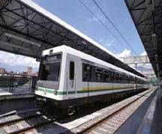
TRAINS

METRO DE MEDELLIN:
The Metro de Medellín is an urban train that crosses the Metropolitan Area of Medellín from North to South and from Centre to West. As one of the first experiences of modern massive transportation in Colombia.

LINES AND STATIONS OF THE MEDELLIN METRO Commercial operation of The Medellin Metro began on November 30, 1995. Since that time, the line has transported hundreds of millions of passengers in complete safety, comfort, and security. The Metro runs like a Swiss watch with a ticket cost of about 50 u.s. cents! Currently there are a total 28 stations. Nineteen serving Line A, 7 on Line B and 3 on the Metrocable.
The Medellin Metro follows the Valley of Aburrá, serving historical, commercial, government, tourist and industrial locations. Medellin's modern transportation system is an equal to other important Latin american systems serving Rio de Janeiro, Sao Paulo, Caracas, Mexico City and Santiago de Chile.
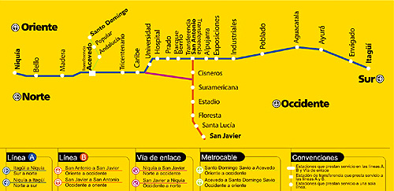
LINE A
Line A is 23,2 kilometers long, and for the most part, follows the Medellin River, joining the two municipalities of Niquia in the North with Itagui in the South. Line A Station names are: Niquía, Beautiful, Wood, Acevedo, Tricentenario, the Caribbean, University, Hospital, Prado, Berrío Park, San Antonio, Alpujarra, Exhibitions, Industrialists, Town, Aguacatala, Ayurá, Envigado and Itagüí. Currently there are a total 28 stations. Nineteen serving Line A, 7 on Line B and 3 on the Metrocable.
The Medellin Metro follows the Valley of Aburrá, serving historical, commercial, government, tourist and industrial locations. Medellin's modern transportation system is an equal to other important Latin american systems serving Rio de Janeiro, Sao Paulo, Caracas, Mexico City and Santiago de Chile.
LINE A
Line A is 23,2 kilometers long, and for the most part, follows the Medellin River, joining the two municipalities of Niquia in the North with Itagui in the South.
Line A Station names are: Niquía, Beautiful, Wood, Acevedo, Tricentenario, the Caribbean, University, Hospital, Prado, Berrío Park, San Antonio, Alpujarra, Exhibitions, Industrialists, Town, Aguacatala, Ayurá, Envigado and Itagüí.
LINE B
Line B began operations on February 29, l996, and is 5.6 kilometers in length with six elevated stations and one at ground level. Line B goes from San Javier, in the West of the city, to Bolivar with Maturín, in the Station San Antonio. It entered operations the 29 of February of 1996.
Line B station names are: San Javier, Santa Lucia, Floresta, Stage, South American, Cisneros, San Antonio.
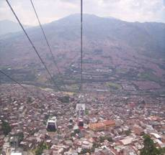
Lines A and B are connected by a third section of tracks which extend from the Caribbean Station on Line A to the South American Station, on Line B. This section of tracks is all at ground level.
THE METROCABLE LINE
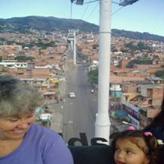
On July 30, 2004 the Metrocable began operations serving a lower socio-economic area with direct connections to the Metro Line. The inhabitants of this Northeastern Sector of Medellin have all benefited from this improved transportation system. Plans call for other Metrocable routes to be established
http://www.metrodemedellin.org.co/portal/

http://youtube.com/watch?v=4-4YYasLhBM&mode=related&search=

TAXIS

There are about two dozen taxi companies with Taxi Stands interspersed throughout Medellin and the adjoining cities. All taxis use meters which when cleared will display the STANDARD MINIMUM FARE. As you get in the cab, check and make sure that the meter has been cleared and shows the minimum fare. If not, remind the driver to clear the meter. If you find a driver that you are comfortable with, and you want to repeat the experience, ask for his/her business card. Get the cards from 3 or so drivers. Put their numbers and names in your cell. Now, it's almost like having your own private chuffers!
PERSONAL SAFETY WHEN USING TAXIS
No matter the CITY or COUNTRY your in.....remain alert.
1. Its best if you or a friend phones the taxi company direct. Or, have the hotel where you are staying, phone. The taxi company will tell you the number of the taxi that they will dispatch to pick you up. When the taxi arrives, compare the numbers for a match. If the numbers are not the same, wave the driver on. DO NOT GET IN THE CAB. Call for another.
2. Be more alert when you hail a cab from the street, especially if you are near a bank, disco, bar, nightclub, expensive store, high end shopping center, etc. or when it's past 10 p.m.

BELLO TAXI MEDELLIN:
It's better not to hail taxis in the street. Especially in Medellin, many taxi drivers were criminals or assassins before, who invested their money in their own car. Many of them may have connections to local kidnapping gangs. So call a taxi company and they'll send one along. Bello is the one that was recommended to me they are very reliable & safe & they will always give you a taxi number when you call. Write it down and match it up to the one that comes and gets you.
444 9999
Http://www.bellotax.com.co
AUTOMOBILE RENTALS

http://www.paginasamarillas.com/pagamanet/web/companyCategory.aspx?ica=276&nca=Automobile+rentals&ici=91&ipa=1&idi=1&nci=Medellín%20&ies=3&nes=%20Antioquia&pg=1&k=20808&tbu=2&tipo=categoria&txb=RENTALS

CELL PHONE RENTALS

JUANCHOS COMUNICACIONES:
Cr 53 94-60
COLOMBIA - Antioquia, Medellín
Phones: (57)(4)5231567

CURRENCY CONVERSION
http://quote.yahoo.com/m5?s=USD&t=PHP&a=1&c=0
www.Oanda.com
CURRENT WEATHER & FOUR DAY FORECAST IN MEDELLIN
http://www.wunderground.com/global/stations/80110.html
http://www.cnn.com/WEATHER/sa/Colom...dellinSKMD.html
LOCAL NEWSPAPER

El Colombiano:
Medellin, Colombia
http://www.elcolombiano.com/an.asp
BANKS
BANCO UNION COLOMBIANO:
Cra. 43A 14-101,
Tel: 266-3858
BANCOLOMBIA:
Cra. 52, No. 50-20,
Tel: 510-7888 Web:
www.bancolombia.com.co
CONAVI:
Cra. 43A, No. 1A Sur-143.
Tel: 510-9000
http://www.conavi.com/
BANCO DAVIVIENDA:
http://www.davivienda.com
BANCO DE LA REPUBLICA:
Cl. 50 #50-21
(094)5767400
http://www.banrep.gov.co
http://www.banrep.gov.co/museo/esp/home.htm
BANCO SANTANDER COLOMBIA:
http://www.bancosantander.com.co
BANCO DE OCCIDENTE:
http://www.bancodeoccidente.com.co
SAFETY IN MEDELLIN
Safety in Medellin is a much-discussed but often-misunderstood topic. Medellin city is as safe as you make it, use the same caution as you would in any big city. Do not, under any circumstances, make any jokes about the use of cocaine or bombs. The Colombian police take jokes as threats, and you may find yourself in a police station explaining yourself to unsympathetic police officers. Under normal circumstances, police officers are usually kind and helpful towards tourists. While the trend in all the major cities and Colombia generally is much improved with all the recent efforts of the Uribe government such as the Democratic Security plan, use common sense. Safe and worthwhile places to visit are the many Tourist Centers and Shopping Malls, the upscale Poblado section, the Las Palmas barrio (restaurants and discos), and the El Centro (Downtown Area). There is plenty to see and do, and you will have an enjoyable once-in-a-lifetime experience. Always change your money at a bank (Conavi or Bancolombia are the two national banks) or at "Moneygramm". "Street changers" offer tempting rates for your dollar, but be on guard. "Street Changers" palm several of the biggest bills for themselves. Do not flaunt large amounts of money around or ware flashy jewlery.
http://usinfo.state.gov/regional/ar/colombia/
http://www.state.gov/r/pa/ei/bgn/1831.htm
HELPFUL TELEPHONE NUMBERS:
Emergency Medellin Telephone Numbers (Police, Fire): "123"
COLOMBIAN NATIONAL POLICE:
Web: www.Policia.gov.co
COLOMBIA DAS (Department of Administrative Security):
Web: www.DAS.gov.co
U.S. STATE DEPT:
Help for U.S. Citizens Abroad:
Web: http://travel.state.gov/acs.html#emr
HEALTH/TRAVEL INSURANCE
WORLD NOMADS: http://www.worldnomads.com/
TRAVEL GUARD:
www.TravelGuard.com
TRAVELEX INSURANCE SERVICE: www.travelex-insurance.com
TOTAL TRAVEL INSURANCE:
http://www.totaltravelinsurance.com/

IMG GLOBAL:
www.imglobal.com

TRAVELERS MED:
http://www.travelersmed.com/
BEST BEACH RESORT NEAR MEDELLIN
BAHIA SOLANO:
http://www.turiscolombia.andes.com/tours_bahia_solano.htm
http://www.webcolombia.com/travel/Bahia%20Solano.htm
SELECTED PUBLIC NOTARIES FOR LOCAL MARRIAGE IN MEDELLIN
NOTERIA SEPTIMA:
LUCIA MEJIA ZULUAGA
Calle 55, No. 46-21,
Tel: 231-6080, 513-3018
NOTERIA TRECE:
DR. MARIO CESEAR ACOSTA
Cq. 5, No. 70-93,
Tel: 412-0433, 411-2928 Web:
www.Notaria13.cjb.net E-mail: notaria13@epm.net.co
NOTERIA VEINTE:
DRA. SILVIA EUGENIA LOPERA UPEGUI
Calle 10, No. 43 E-44 Poblado,
Tel: 266-1427 Fax: 266-0651
E-mail: silviapera@epm.net.co
U.S. CONSULATE-APPROVED DOCUMENT TRANSLATORS IN MEDELLIN
MARIA ISABEL CARDENAS:
Cra. 45, 9S-12,
Tel: 321-4420 Fax: 321-8565
CARLOS E GIL-ATEHORTUA:
Calle 49, #DD 81C-36,
Tel: 421-5040, 234-1542
JANE S LOSADA, URB. ALTAMIRA:
Cra. 72A, #79-61, Bloque 37, Apto. 535, AA #60562,
Tel: 437-4060
HELPFUL WEBSITES FOR HER/HIS SOCIAL ADJUSTMENT TO THE U.S.
1. www.Path2USA.com
2. www.ForeignBorn.com

IMMIGRATION, VISA & PRENUPTIAL ASSISTANCE

USA IMMIGRATION ATTORNY:
This service enables you & your fiancée or spouse to be together as quickly as possible, thereby minimizing painful separation and stress. Thus ultimately saving you valuable time & money.
http://www.usaimmigrationattorney.com/whyuseus.html

US IMMIGRATION AND NATURALIZATION SERVICE:
http://www.uscis.gov/portal/site/uscis

K1-VISA INFO:
Regardless of the country in which your fiancee resides, the K1 FIANCEE VISA is the only proper visa for her to use to enter the U.S. for the purpose of marriage. If she enters the US on another type of visa or visa waiver you can certainly legally marry her. However, she will then need to depart the U.S., obtain a K3 spousal visa at the U.S. Consulate in her country of residence and reenter the U.S. on the K3 visa in order to be able to remain in the U.S. permanently as your spouse.
http://www.visajourney.com/faq/k1faq.htm

CLUBS
http://www.yellowpages-caribbean.com/Countries/Colombia/result.cfm?country=CO&Category=Discotheques&getkey=&CompName=&GetCity=&GetDept=&Island

MEDELLIN PARTY SITES

http://www.enfarrados.com

http://www.medellin2night.com

http://www.medellinstyle.com

http://www.pegateya.com

http://www.rumbiaderos.com


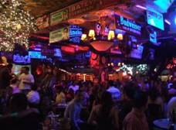

DISCOTECA MANGO’S
(Cr 42 No. 67A – 151)
Tel: 277 61 23

http://www.discotecamangos.com
http://youtube.com/watch?v=Hfer74p0vf4&mode=related&search=medellin
http://youtube.com/watch?v=B4HGhaRIcR0
Set in an early western theme, they have numerous stages with Mangos dancers in skimpy outfits gyrating and grinding to various types of music. There is a cover of $10K and drinks are not cheap. Target identification is another matter. You would have to spend several nights there and learn to read the room before you could spot who was available and who was not. Many are with dates, others are with groups of friends. For the most part, it is a place to see and be seen for the locals as the prices keep out all but the well to do or those who get lucky to find someone able to pay. Many save their money to be able to go once per month. This is a place to take a date IMHO, at least on your first couple of visits. It is a great place to party with a group of friends. You will see more cleavage and silicon in one place than you have probably ever seen in any one place in your life. They are only open 4 nights per week, Thurs. through Sunday so be advised in your planning.

DISCOTECA ELEKTRA:
Cl 72 # 42-69 Itagüí
COLOMBIA - Antioquia, Medellín
Phones: (57)(4)3731000
http://www.discotecaelektra.com

DISCOTECA ABUELO GOZON (DISCOTECA ABUELO GOZÓN )
Cl 69 Sur 44-08 Sabaneta
COLOMBIA - Antioquia, Medellín
Phones: (57)(4)2880114

DISCOTECA ABUELO GOZÓN:
Cl 69 Sur 44-08 Sabaneta
COLOMBIA - Antioquia, Medellín
Phones: (57)(4)2880114

EL BLUE: This is a popular place with cross-over muic (a mix of rock and local music). It's popular with gringos and 'gringo hunters'.

TRILOGIA BAR:
Cra. 43 G N. 24 – 08
262 63 75
Live music.

REPUBLICA:
This place is opposite of El Blue offers electronic music and local music.
OZ TRIADA:
Cra. 38 N. 8 – 20
311 57 81
Its decoration is like a Night club from Europe. All type of Music like Electronic and Dance.
PALMAIA: Cra 42 No. 85B-121 (Autopista Sur)
3 62 57 57
Prices Between: 50.000 – 1’200.000
It is the biggest night club in Medellin, it’s inspired on beach and tropical locations,
It has a 3000 people capacity.
It has a volleyball court, boxing ring and gorgeous live dancers.
B-LOUNGE: An electronic disco with rich, beautiful women as is...
LA KASA: Both good on Thursday nights as it's Ladies Night.
CIRCUS: Cover: $ 10.000 pesos. Prices between: $ 35.000 and 150.000 pesos.
Different Music everyday: Wednesday: Romantic Music.
Thursday: Salsa music and Regetton.
Friday: electronic music. Saturday: Crossover. Is a venue with great views over Medellin. Very popular with the beautiful, in-crowd and normally plays cross-over music.
MACONDO:
Cover: $ 10.000 pesos
Prices between $ 35.000 and 150.000.
Live singers and Shows. Tropical environment.
SAM PUES:
Cover: $ 10.000
Prices between $ 30.000 and $ 90.000 pesos.
Singers and crossover music. Great place to dance.
UNIVERSAL:
Cra 42 No 72-125 Autopista Sur
2852020
Dancers Shows and crossover music. Another place close to Mangos & rivals Mangos for size and popularity but generally has a much younger clientele
BABYLON:
Las Palmas cra 38 No 26-260
3818169
Prices: Between $ 35.000 and $ 70.000 pesos
Cover $ 10.000 pesos
Thursday: Open
ES LA BON: A great place to watch, or if you can, dance salsa. It's located in the centre so some precaution is necessary.
DÉJÀ VU NIGHTCLUB:

CANALON: Carrera 40 No 75 sur-25
2887408
Cover: $ 10.000 pesos.
Thursday to Saturday: 7:00 p.m. to 3:00 a.m.
Live shows, singers and dancers.
DJs and contests.
Music: Crossover
FLOW:
(close to Parque Lleras, on 10a street)

ZONA LIBRE-BAR:
Cl.52A 50-19
Phone: (57-4) 511-5111
LAS PALMITAS DISCO:
Cra. 38 N. 26 – 41
381 51 04
Live shows
TIBIRI:
Calle 70 & 48d?
Old School Salsa Bar If If you like to spend $ and see midgets, go to Mangos. It´s the hot place. Club Blue is 5000 to get in ($2.50) and includes 2 beers it´s a standard club. If you want to go to a hole in the wall Salsa club with great atmosphere try Tibiri. No sign, just stairs to the basement. It´s known as a dive with the best music.
RESTAURANTS
http://www.medellin.im/restaurants.htm
http://www.yellowpages-caribbean.com/Countries/Colombia/result.cfm

LA DOCTORA:
Great typical Colombian cuisine.
The place is semi-enclosed (like many restaurants) and the food is great - meats, poultry (no fish I think).
Located near the Oviedo Mall right in back of the Hotel Poblado Plaza.
If the taxi doesn't know the restaurant, they know the hotel. (Lunch and Dinner)
LAS PALMITAS:
Cra 38 # 26-41
232 7199
Prices between: $17.000 - $23.000.
Specialty: International food
Comments: It has a very beautiful view of Medellín, located on one of the highest hills. Its decoration is typical from Antioquia with some oriental decoration like red and green lights, it has semi-private wooden "cubicles" providing more privacy.
Typical Colombian cuisine and a good place to go for coffee and dessert.
Las Palmitas Disco is adjacent and a good place for drinking and dancing
Open for dinner and I'm pretty sure lunch as I passed by there at lunchtime and there were a lot of cars in the
parking lot.
Las Palmitas Disco is adjacent and a good place for drinking and dancing.

ANGUS BRANGUS PARILLA BAR:
Cra 42 # 34-15 Via Las Palmas
232 1632 - 2321652
Prices between: $25.000 - $59.000
Specialty: Meat, Steaks, Paella and Seafood
Comments: Good service, they have the best meat in Medellín.
Singers and Alive Shows.
Music: Soft Music
Monday - Saturday: 11 a.m. to 12 p.m.
Sundays: 11:00 a.m. to 5 p.m.
SAN CARBON:
Bar - Restaurant
Exact address is: Via Las Palmas x Transversal Inferior Cll 14 # 30-10
312 7521 - 311-7602
Prices between: $22.000 - $39.000
Specialty: Meats
Music: Soft Music
Great steaks and a great view of the city as well. They make a nice margarita and have a good wine list
It's not far from Las Palmitas, but not as well known. I've been there for lunch and dinner.
They make a nice margarita and have a good wine list.
One thing - I gave the taxi driver the restaurant's business card and he drove me to Las Palmitas.
He didn't even know the address. But just down the road from Las Palmitas is a billboard with San Carbon on it saying it's the next right.

LAS CUATRO ESTACIONES: (The Four Seasons)
One of the best restaurants in Medellin, great service, great food - a place that's sure to impress.
It's on the main avenue 43A that runs through Poblado, a little past the Dann clarlton hotel going towards centro - up a very steep hill
LA FONDA DE SALVATIERRA:
Cll 16 # 28 – 170
311 8350
Prices between: $17.000 - $40.000
Specialty: International food
Comments: They have horses that dance in the Fonda; good customer service that makes you feel at home.
Music: Live music and Soft Music
ASIA:
Cll 16 # 30- 145
268 6810
Prices between: $15.000 - $17.000
Specialty: Chinese Food
Comments: Nice view of Medellín, good service, excellent cooks.
Music: Classic and Chinese Music
IL FORNO:
Cra 25B #18A Sur 137 San Lucas - El Poblado
317 12 25
Prices between: $7.000 - $14.000
Specialty: Italian Food, Pizzas, Sandwiches, Pasta
Comments: It has very good customer service and the food is very well prepared
Music: Soft Italian Music
TONY ROMAS:
Inside Hotel Dann Carlton
Piso 19 bar restaurante giratorio
312 41 41
Specialty: BBQ Ribs, BARBECUED Super Meal: chicken, ribs and baby beef
Monday - Saturday: 11 a.m. to 3 p.m. and 6 p.m. to 12 p.m.
LA PROVINCIA:
Cll 4s # 38a - 4
266 30 87
LA GRAPPA:
Calle 8a # 37a 01 Poblado
3127266
Prices between: $9.000 - $26.000
Specialty: Italian food
Comments: Mediterranean style, all of the products are imported, the service is excellent.
Music: Blues, Jazz and 80´s
LA DOCTORA:
Cra.43 75 Sur 65 Sabaneta
288 12 54
FRUTOS DEL MAR:
Cra 43 B 11-51
266 5766
Prices between: $24.000 - $55.000
Specialty: Sea Food
Comments: Small place, the food is very good, the decoration has a Fish Tank, Sail Boat and a lot of Art Pictures on the walls, the service is excellent.
Music: Classic
EL RANCHON:
Cll 10 # 43 E 064
352 4585
Prices between: $12.000 - $20.000
Specialty: Typical Food
Comments: The decoration of the place is very typical; the environment feels like a typical farm from Antioquia with art crafts and food. It’s a very familiar place.
Music: Typical Colombian Music
PRIMOS:
Cra 25 B # 18 A SUR 137
317 1852
Prices between: $6.000 - $22.000
Specialty: Salads, Hamburgers, Sandwiches and Meats
Comments: Variety menu, they have a lot of type of additions depending on the plate, good service and a nice place to talk.
Music: Classic
IN CHINA:
Cra 30 # 7A-310
2667397
Prices between: $17.000 - $32.000
Specialty: Chinese Food
Comments: A very beautiful place, selected decoration, nice outdoor dinning with a small fountain, good service and the cooks are Chinese.
Music: Chinese music
EL ZOCALO:
Cra 43 B # 11- 84
311 4217
Prices between: $10.000 - $23.000
Specialty: Mexican Food
Comments: Nice restaurant, good service, variety on the menu, spicy and delicious food.
Music: Mexican Music

HATO VIEJO:
#1: Cll 16 # 28-60 Telephone: 2685412
#2: Centro Comercial Oviedo: 4th floor 3211965
Prices between: $16.000 - $30.000 + iva
Specialty: Typical Food and Steaks
Comments: Good service, excellent prices, nice place.
Music: Typical old music from Colombia and Rancheras
Monday - Saturday: 12 p.m. to 2 a.m.
Sundays: 12 p.m. to 5 p.m.
LA FRAGATA:
Address: Cl.11 No.36-14 (Zona Rosa, Blvd. del Park 10)
City: Medellín , Department: Antioquia
Phone: (57-4) 268-5578 / (57-4) 268-5475
Fax: (57-4) 268-5387
E-Mail Address: fragatamed@epm.net.co
Great seafood restaurant. Food and service are exemplery.
The only thing is it's a very formal setting (no dress code - saw other people in very casual attire)but if you take
someone who's not very sophisticated, they may be intimidated.
It's attached to a Hotel, the Park 10 I beleive.Also, as point of reference, with La Fragata on your left, if you
continue up the hill, you'll find San Carbon on the left-hand side about a mile up.
LA AGUACATALA:
Address: Cra.43A 7S-130
City: Medellín , Department: Antioquia
Phone: (57-4) 321-4830
Serving typical Paisa cuisine, this place has been around for 40 years.
We ate outside overlooking a very nice garden. Not expensive - the check for 5 people was under $50.00
Located on Cra 43 near the Oviedo Mall.
LA CAFÉ DE GRIS:
Oviedo Mall restaurant.
Smartly located where you can see beautiful women come and go from the mall.

FATTO EN CASA PODESTA:
Cll 9 Sur # 29 D 76
268 6168
Prices between: $14.000 - $38.000 + iva
Specialty: Italian Food
Comments: Big house, good service, food well prepared.
Music: Soft music and Italian Music
BUFFALO RESTURANTE & BAR:
(Cra 43 B No. 16-91) not to far from the Dann Carlton.
They make the best martini in Colombia.
MONDONGOS:
Address: Cl.10 No.38-38 (El Poblado)
City: Medellín , Department: Antioquia
Phone: (57-4) 312-2346 / (57-4) 268-7003
Fax: (57-4) 268-7003
E-Mail Address: mondongos@epm.net.co
When you guys are in Medellin you have to check out Mondongo's. It serves authentic Colombian food at very reasonable prices. Three of us went and the total bill including drinks was only 30,000cop and we all ate our fill. It was great, now there are 2 of them the one we went to had a balcony where you can sit outside and girl watch. There is a nightclub right across the street that had some very sexy paisas coming & going.
TRAMEZZINI:
Calle 9A, No. 37-56,
Parque Lleras. Tel: 311-5617.
Fantastic Italian restaurant

CREPS & WAFFLES:
Cra 36 # 10-54
311 5042
Prices between: $7.000 - $25.000
Specialty: Crepes and waffles
Comments: All the employees are women, they have very good service, and the food is well prepared, variety in the menu for all types of tastes.
Music: Soft Classic

AVE MARIA:
Bar – Restaurant
Cra. 38 N. 9 A - 13
311 56 23
Specialty: International food.
Prices between: $19.000 - $22.000
Discount: 12 pm – 7 pm 40% off (taxes included, it does not applied to sea food)
Comments: One of the most traditional places in Parque Lleras,
Music: American music.
THAICO:
Bar – Restaurant
Cll 9 A N. 37 – 40
311 56 39
Specialty: Thai food
Prices between: $17.000 - $20.000
Discounts: 12 pm – 7 pm %50 off, 3 * 1 in cocktails, 2 * 1 aguardiente, rum and beer.
Comments: It is one of the most popular places in the city, not only their prices but the food and the environment.
Music: All types of music
A good place for after hours
BASILICA:
Bar – Restaurant
Address: Cra. 38 N. 8 A 42
Telephone: 311 7366
Specialty: Sushi and meat
Prices between: $19.000 - $25.000
Discount: 12 pm – 5 pm % 30 food and national drinks
Comments: Outdoors, the cocktails are very popular.
Music: Dance, classic rock.
TRINDA:
Bar – Restaurant
Address: Cra. 38 N. 8 – 20
Telephone: 311 5781
Specialty: The place, International Food, Langoustines SAMURAI
Prices between: $6.400 - $35.000
Discount: If you have the Triada Card 20%
Comments: It’s a different place to eat and have fun with your friends. It’s very big and has a good variety of international food. They also have a night club on the second floor
Music: CROSSOVER
CAFE ORLEANS:
Bar – Restaurant
Address: Cra 39 8-100
Telephone: 3520187
Specialty: Spanish Food
Prices between: Less than $20.000
Comments: Very good service, good wine, nice place, good food and prices
Music: Spanish music
DRIVERS/GUIDES

ALVARO TORRES:
316-252-2882 from Medellin
011-57-316-252-2882 from U.S. to arrange for airport pickup.
I personally used Alvero he speaks perfect English. He really knows his way around; Alvaro is a great guy and my highest recommendation

HECTOR:
Hector, Nice guy speaks broken english but you can get your point across to him. I have also personally used him.
3156614187 y 3007861119
FERNANDO:
Fernando, no english but knows every thing in Medellin great guy really good personality a lot of fun to party with. I have used him too.
315-518-1155
GUSTAVO:
Gustavo has lived in the USA, speaks very good English, understands and can relate to your needs.
311-388-3861
MEDELLIN INFORMATION SITES
http://www.medellin.gov.co/
http://www.webcolombia.com/cities/medellin/

http://www.gringoincolombia.com/links.htm
http://poorbuthappy.com/colombia/
http://www.medellininfo.com/
http://www.colombianblog.com/phpBB2...opic.php?p=9933
http://www.colombialink.com/
http://www.gringoincolombia.com/
http://www.colombiafarmvacations.com/information-about colombia.htm
http://www.flowerstocolombia.com/
http://chicahunters.com/
http://www.travelpod.com/
http://www.colombiaemb.org/
http://www.turismocolombia.com/home.asp?IdCompany=127
http://www.ecotet.com/visitcolombia/medellin.htm
http://www.artepaisa.com/
http://www.mundopaisa.com/MEDELLIN/indice.htm
http://www.LoPaisa.com
http://www.locombianos.com/menu.htm
http://juanvaldez.com/

http://www.yellowpages-caribbean.com/Countries/Colombia/index.cfm
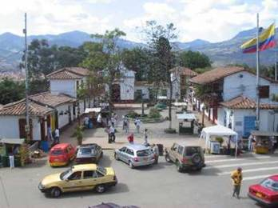
STUFF TO SEE AND DO IN MEDELLIN
PUEBLITO PAISA:
Pueblito Paisa is a replica of an old Antioquian town. This replica of a typical Paisa village is situated on top of the Cerro Nutibarra. With souvenir shops and open air cafes it's a nice place to relax; besides it provides an amazing view over that nice red city.
It truly does give you a good idea what the typical village of the area looks like, with its colorful houses, a tiny local church ( with some real trippy statues a must see), courtyards and patios, small shops, that are packed full of crap for the tourists, there is also a fountain in the middle of the village. There is a place here where you can get a great panorama of Medellin. Just go across the parking lot up the stairs follow the sidewalk and there it is.
Pueblito Paisa & Santa Fe de Antioquia, look almost exactly the same; the town is built up in the exact same way as the replica indicates. So if you don't have time to go to the surrounding towns, the Pueblito Paisa gives you a good idea of the local villages, and the view is truly breathtaking.
http://www.pbase.com/kmilo/pueblito_paisa

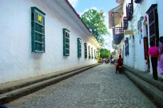
SANTA FE DE ANTIOQUIA:
This is a really nice little town in the mountains about 100 km from Medellin.
Santa Fe de Antioquia is the oldest town in the region. It was founded in 1541 and prospered in the days of Spanish Colonial rule. The town is located some 80 km north of Medellin, on the road to Turbo. A typical paisa town, a really amazing place and the bus ride up the mountains is really cool and gives a great view on the surrounding villages and nature.

The historic centre is breathtaking and a stroll through the old streets gives you the chance to admire the many decorated doorways of the houses, the patios full of flowers and the carved wooden guards. The doors of the old colonial houses are enormous, fit for a giraffe.

Main sights include the Iglesia de Santa Barbara, the Museo del Corral and the Museo de Arte Religioso. Six km east of town is the Puente de Occidente, an unusual bridge over the Rio Cauca, which was built by a famous engineer. It was one of the first suspension bridges in the world and possibly the first in South America.
Directions: Just take a bus from the terminal or taxi Hector charged me 150.000cop for the trip. http://youtube.com/watch?v=RR1ZAXaWbac
http://translate.google.com/transla...6lr%3D%26sa%3DG

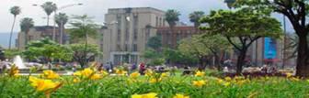

MUSEMO DE ANTIQUIA:

Carrera 52A Nro. 51A - 29
Telephone 251 36 36, 2 51 90 08
Schedule: Tuesday to Friday of 9:30 a.m. to 5:30 p.m.
Saturdays 9:00 a.m. to 2:00 p.m.
This museum houses many statues and paintings of Medellin's most famous artists, Fernando Botero etc..
There is also a great section of modern Latino art. There are people walking throughout the museum who are happy to explain the artwork.
http://www.museodeantioquia.org
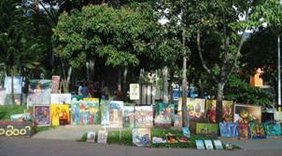
PARQUE LLERAS:
Calle 11 & Carrera 39
The cabbie left us in a tree-lined park surrounded by enchanting sidewalk cafes. During the day, restaurants in Parque Lleras offer a variety of international cuisine and typical Colombian dishes. After dusk, however, the tables are moved aside and the party begins. The sounds of Colombia came alive once we exited the cab and within minutes I was learning the sultry moves associated with la cumbia.
This is a small but very lively park with nice landscaping and fountains.
It is surrounded by many cafes and restaurants, and its big trees offer a lot of shade.
The Parque Lleras is packed to gills on weekends with locals who come here to numerous bars and discos.
And even during the week the restaurants are full and the place is buzzing with activity.
The most popular discos here are Blue and Folia, but if you visit one and feel like changing atmosphere,
another club is literally half a block away. A fantastic place to girl watch.
EL PARQUE DE LOS PIES DESCALZOZ: (Park of Bare Feet)
Carrera 57 Not 42 - 139
This is one of the most popular parks in Medellin. Comfortably surrounded by trees, it provides a perfect hiding place for couples and lovers, who look for privacy under the surrounding trees and bushes. The park also has several open air cafes which provide a good place for people watching and relaxing. On the other side of the park you'll find huge chess-boards, where
In both settings, children and adults are educated by official guides free of charge on how to appreciate open space. Located near the city’s Planetarium, the Park of Wishes is a place to observe the cosmos and interact with eleven different astronomical exhibits.
The Park of Bare Feet, on the other hand, brings patrons down to earth to experience a sensual zen garden, a gaudua tree forest and an interactive museum. The museum displays nearly 200 hands-on experiments explaining society’s energy sources.
http://youtube.com/watch?v=8-GpkwR39qM&mode=related&search=

PARQUE POBLADO:
Carrera 43#10
Las Palmas (section of town with many restaurants and night discos, very busy on Friday and Saturday nights).

PALACIO DE LA CULTURAL: “Rafael Uribe”
Cra, 51 N. 52-03
251 14 44
Hours:
Mondays to Fridays: 8:00 a.m. to 5:00 p.m.
Saturdays: 8:00 a.m. to 4:00 p.m.
With its florid gothic style, it occupies the old premises of the Antioquia Government Palace. It is no doubt one of the most representative architectural works in the city. Its design and construction is the work of Belgian architect Agustín Goovaerts (1885 – 1939). Its Art Gallery, on the ground floor, hosts artistic exhibitions, and visitors have the opportunity to see them and also to take part in workshops and discussions around the topic.

MUSEO EL CASTILLO:
Cl.9 sur N. 32 – 269
Tel. 2660900
CASA MUSEO PEDRO NEL GOMES:
Cra. 51 B N. 85 - 24
Tel. 2332633
MUSEMO INTERACTIVO:
Empresas Publicas de Medellín
Cra. 47 N. 42 – 139
Tel. 3806954
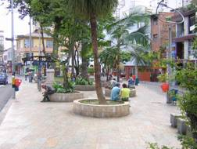

PARQUE PERIODISTA: Is a Parque (square) right in the center of the city. It is where the 'bohemian' and 'alternative' people meet. The bars play music varying from reggae and old salsa to alternative rock. You will find the majority of the people on the street, instead of in the bars though.

METROPOLITAN CATHEDRAL: National Monument was declared and its construction stands out by its romantic style. By his cooked mud structure, it is considered greatest of the world since altogether it counts on 1.120.000 you marinate. Its construction began in 1875 and was finished in 1931. By its size the seventh greatest one of the world is considered and has a complete museum of religious art.
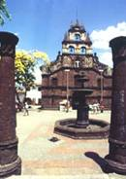
INGLASIA DE LA VERACRUZ: It was the second church constructed at the end of the XVIIth century. In that epoch it was known as Hermitage of the Veracruz of the Strangers of the Outsiders because the group of people that carried out the work was known as the Congregation of Outsiders and European.. Nevertheless, in 1803 it was reconstructed because it was threatening to fall. The front is stone that concludes in a bell tower, that does some time lit up without bell because an important person caused he removed it to manufacture a cannon.

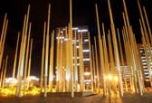
PLAZA DE CISNEROS:
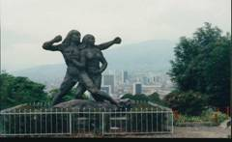
This plaza is in the heart of the city, it borders some beautiful buildings from the 20's, the EPM bibliothec, and a sector that was full of drug and poverty many years ago, but is now a place to visit and have a great time. http://youtube.com/watch?v=2DnN6tmZoJU&mode=related&search=

CERRO NUTIBARRA:
The mountain of Cerro Nutibarra is a great place to get a nice view of Medellin from. It's not too high, so the climb is not that difficult. And on top of the mountain is the Pueblito Paisa - a replica of a typical paisa town, which is full of souvenire shops and street vendors. A nice place and an interseting activity.

PRADO: A neighborhood, formerly it was the wealthy neigbourhood of the city so many huge houses were built there, it still has some of these beautiful old houses, though it should be visited with caution as it's near the center of the city.
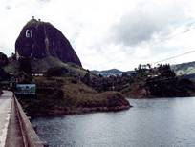
THE BOSTON PARK: An attractive area that leads down to the main promenade La Playa where people can be found gathering at night to see street acts.
LA PIEDRA DEL PENOL: (a.k.a. Peñon de Guatape or just Penol)
This is a 200m high rock dominating the landscape. A climb to the top will cost you a few thousand pesos, but the view is breathtaking. There are busses going about every hour from the Medellín north bus terminal.

TEATRO METROPOLITANO:
Calle 41 No 57-30
Tel. 232-4597
http://www.elcolombiano.com.co/BancoConocimiento/9/9_teatro/9_teatro.asp

PLANETARIO DE MEDELLIN:
http://www.astroceta.net/planetario/
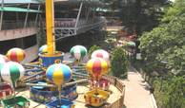
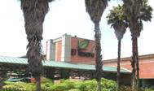
SHOPPING MALLS
EL TESORO:
Cra. 25A #1ASur-45
Tel.: (57) 321 1010
http://www.medellininfo.com/shoppin...ltesoro.com.co/

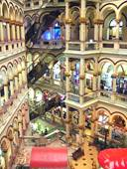
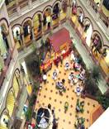

CENTRO COMERCIAL PALACIO NACIONAL:
Cra. 52 #48-45 Carabobo entre Pichincha y Ayacucho
Tel.: (57) 513 4422
http://www.medellininfo.com/shoppin...ioNacional.html
This has got to be the most unique mall I have ever seen

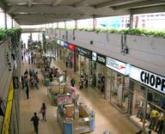

MAYORICA BOULEVARD:
Cll. 51 Sur #48-57
Tel.: (57) 373 0335
http://www.medellininfo.com/shopping/mayorca.html

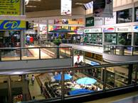

MONTERREY:
Cra. 48 # 10 – 45 Av. Las Vegas
Tel: 268 01 00
http://www.medellininfo.com/shopping/monterrey.html

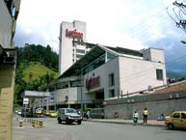
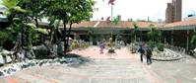
SAN DIEGO:
Cl.33 No. 43-66
Tel. 232 0624
http://www.medellininfo.com/shopping/SanDiego.html
(the oldest comercial center),


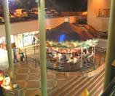
OVEIDO:
Cra. 43A #6 Sur-15
Tel.: (57) 321 6116
(next to Hotel Four Points-Sheraton).
http://www.medellininfo.com/shopping/oviedo.html

UNICENTRO:
Cra. 66B #34-76
Tel.: (57) 265 1116
(also very nice)

CAMINO REAL:
Cra. 47 #52-86
Tel.: (57) 512 7161 (downtown location, very nice),

PLAZUELAS DE SAN DIEGO:
CLL. 33 #43-16
Tel.: (57) 262 1485
PLAZOLETA DE LAS AMERICAS:
DG 75B #2A-120
Tel.: (57) 341 8073
http://www.pmamericas.com/VBeContent/home.asp
OBELISCO:
Cra.74 #48-37
Tel.: (57) 230 5068
LA FONTERIA MALL:
Cra. 43A #18Sur-174
Tel.: (57) 313 8980
CENTRO TEXTIL MOLINO VIEJO:
Cll. 49 (Ayacucho) #56-17
COLOMBIAN ONLINE SHOPPING

MERCADOLIBRE
http://www.mercadolibre.com.co/home_visitor.html

VIRTUAL EXITO
http://www.virtualexito.com/

FLOWERS & GIFTS TO COLOMBIA
http://www.flowersandgiftstocolombia.com

CRAIGSLIST COLOMBIA
http://colombia.craigslist.org/

EXITO SHOPPING CENTERS
These are like Wal-Mart superstores they are a combination a grocery & all purpose store.
Schedule:
Monday to 9:00 Saturday a.m to 9:00 a.m
Festive Sundays and 9:00 a.m to 7:00 p.m

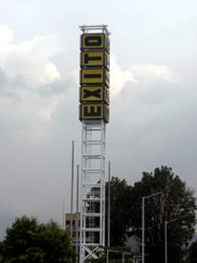
EXITO SANDIEGO:
Street 34 N° 43 - 65
Telephone: 232 0455/232 1950
EXITO UNICENTRO:
Cra 66A N° 34 To - 25
Telephone: (054) 265 1177/235 4192
EXITO COLOMBIA:
Cra. 66 Not 49 - 01
Telephone: (054) 430 65 00
EXITO SAN ANTOINO:
Cll. 48 Not 46 - 115
Telephone: (054) 251 00 10
EXITO POBLADO:
Cll. 10 Not 43 and 135
Telephone: (054) 319 72 00
EXITO LAURELS:
Cra. 81 Not 37 - 100
Telephone: (054) 413 24 24
EXITO GUAYAQUIL:
Cra. 52 To Not 47 - 07
Telephone: (054) 513 00 12
.
INTERNET CAFE'S
ONLINE:
Carrera 37 No 10a-54
Price - US 1, 5 Type - General
Tel.-(574) 3112955
http://www.cafeonline.com.co
PUNTO WEB CAFÉ & INTERNET:
Calle 43 Cra 69A Esquina
Mexican Food, Colombian Food, hamburgers, beverages, cafes, licor, music. 4 Computers, printer service
Price - $3 Hours – 10am–10pm
ALFA OMEGA:
Cra 70 #47-34
15 min = 500pesos / 1hr = less than a dollar
http://www.aocomputadores.com
APARTMENT/HOTELS
http://www.colombialink.com/hoteles...IN_HOTELES.html

http://www.laguiahotelera.com/web/companycategory.aspx?ipa=1&npa=COLOMBIA&ies=*&nes=%20TODOS&idi=2&type=category&txb=Hotel&tbu=&ipg=1&nci=Medellin&k=10887&nca=&ica=2859
http://www.vacationvillas.net/holid...mbia/p43194.htm
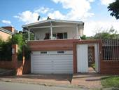
HOSTELS
BLACK SHEEP HOSTEL:
The Black Sheep Hostel is located in the best area of Medellin. Only five minutes walk from the Metro Station Poblado and aminutes walk from a major bus route
Transversal 5A #45-133, Patio Bonito, Medellin
http://www.blacksheepmedellin.com


CASA KIWI HOSTEL:
Casa Kiwi is THE place to be in Medellin. It's three blocks from all of the action of the Zona Rosa,
Carrera 36 # 7 - 10, Medellin, Antoquia
http://www.casakiwi.net

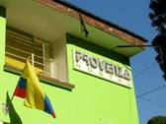
PROVENZA HOSTEL:
The Hostel Provenza is located just two blocks away from the busy Zona Rosa, where you can
find all kinds of food, drinks and entertainment.
Carrera 35 # 7 - 2, Medellin, Antioquia
http://www.provenzahostal.com/English.html

PALM TREE HOSTEL:
Cra 67 #48D-63, Tel: 4 260 2805
http://www.palmtreemedellin.com/

HOSTAL MEDELLIN:
Carrera 65 # 48-50
TEL: 2300505
The Hostal Medellin is one block from the Metro station Suramericana. It is a very nice Hostel with free coffee and tea. Also we offers TV with DVD, Internet, hot showers, washing machine, cook opportunity, garden with grill place, hammocks, tourist information, garage, kiosk and much more.....
http://www.instantworldbooking.com/services/reservation/view_destination.php?dest=Hostal%20Medellin&searchregion=Medellin&subcontinent=Colombia&PHPSESSID=fd3dedcc81141c893515b342968cbc5b

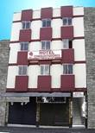

HOTEL CONQUISTADORES:
Carrera 54 # 49-31
Tel. 512 3232
http://webteam.com.co/hconquist/ http://www.instantworldbooking.com/services/reservation/view_destination.php?dest=Hotel%20Conquistadores&searchregion=Medellin&subcontinent=Colombia&PHPSESSID=fd3dedcc81141c893515b342968cbc5b
f
APARTMENTS

ORANGE SUITES:
Calle 8 Nº 43C-37 El Poblado
574] 268 9516 - PBX: [574] 268 7050 - Fax: [574] 268 1141
http://www.travelers.com.co/med/oran/oran_eng.html

THE APARTMENT: Cra 42#7ASur-92 Tel: 4 321 2832
Single room rental in a luxury 3-bedroom apartment in El Poblado, close to the Zona Rosa and public transport. It is also easy walking distance to a large supermarket and one of the best shopping centers in Medellin. It is fully furnished, has free internet, cable TV and one of the best views in Medellin. The apartment complex also contains a pool, squash court, gym and 24 hour security
http://www.theapartmentmedellin.com/

MEDELLIN APARTMENT INFORMER:
http://www.medellin.im/

TATIANA USUGA:
tatiana_usuga@hotmail.com
fax= (574)2386231 home= (574)3415956 cell=(57)3117616439
http://new.photos.yahoo.com/tatianausuga/album/576460762356757318
http://new.photos.yahoo.com/tatianausuga/album/576460762380134060
this third link is a mix of different apartments
http://new.photos.yahoo.com/tatianausuga/album/576460762380198284
COLOMBIA HOME APARTMENTS: Calle 57 41-24 They offer fully furnished Medellin Apartments with fast Internet and more Call Ana +57 3108829556 or with Skype r01636913433 or Miami +1 3054073879 http://www.colombia-home.com/
MEDELLIN APARTMENTS:
http://www.medellinapts.8k.com/
B.R. EJECUTIVOS LTDA: http://www.brejecutivos.com.co/home.htm
REAL ESTATE
http://www.viviun.com/Real_Estate/Colombia/
http://www.paginasamarillas.com/pagamanet/web/companyCategory.aspx?ica=2539&nca=Real+Estate&ici=91&ipa=1&idi=1&nci=Medellín%20&ies=3&nes=%20Antioquia&pg=1&k=20808&tbu=2&tipo=categoria&txb=REAL+ESTATE
MAPS OF MEDELLIN

These are the best Medellin maps I could find you can zoom in & actually find the streets. I just wish there was a place where you can type in an address and it would point to it like Expedia.
MAPORAMA:
http://world.maporama.com
MAPAS LATINOS: http://MapasLatinos.com

MISC. MAPS:
http://www.medellin.gov.co/alcaldia/jsp/modulos/V_medellin/obj/pdf/AFICHE.pdf
http://www.presidencia.gov.co/prensa_new/mapa/colombia_mapa_oficial.pdf
http://www.presidencia.gov.co/prensa_new/mapa/colombiafisico.pdf
http://www.presidencia.gov.co/prensa_new/mapa/mapapolitico.pdf
http://www.invias.gov.co/info/mapas/Antioquia.jpg

OMNI MAPS:
You can order a street map of Medellin from Omni Resources for $14.95usd Scroll down to Colombia Travel and City Maps then scroll down a bit further to Medellin & click to order.

http://www.omnimap.com/catalog/int/columbia.htm

MONGERS SECTION

MASSAGE PARLORS-(CASAS)
The names have been well reported but on the high end, Loutron, to the low end, New Life, they all offer similar services, just at different prices. There is also very little difference in quality of the line up from place to place and most have similar presentation methods; You enter, sit in a comfortable reviewing area, the girls enter one at a time draped in short smocks, open them to reveal bikinis or lingerie, turn, replace their outer , garment, say their name, ask "com permisso" and leave. It is a great idea to have a pen and paper in hand as there will be 6-15 girls per place depending on the day of the week and time of day. Many times, you have to ask for a second showing or a review of a select few before making your decision. Evenings are best for quantity. Quality is a daily toss-up depending on who is having their period, is sick, has a sick child or is occupied when you arrive. Most of the girls will have had some training in massage therapy but do not expect a 5 star, leave you wobbly kneed with aching muscles massages. Take it as an opportunity to relax and get to know your girl.
All are closed on Sunday's. Only New Life is open Sunday. Another option is to contact Alvero
(English speaking taxi driver) to see if he can round up a cutie for you.
LOUTRON:
(CRA. 32 # 2 Sur 47)
Phone: 311-1179
Daytime massage House open Mon. to Fri. from noon to 10pm or till 9pm on Sat.Best
Full Service massages are $160,000 for an hour approx.
I suggest you go early (around noon to 2pm). Going late will mean you will get a girl that is tired and will not likely perform as well as she would have in the early afternoon. Keep in mind that Loutron ($160,000 cop/1hr) offers quality girls and the prices are double than their sister locations. At Loutron you will find a large facility with multiple indoor and outdoor rooms for reviewing or chatting with your selection. Outdoors in the rear of the building, you will find terraced sitting areas, a pool table, an outdoor thatched roof bar and a sauna. Probably, and this is pure assumption on my part, because it is in the upscale Poblado area of Medellin, you will pay almost double of what you will pay in other casas. Yes, the rooms are nicer, larger, well appointed and clean but the lineup of girls is not that much more spectacular than other casas in the city.
ENERGY:
(CRA. 74 # 49-101)
Phone: 436-1131
Another daytime massage house open from noon to 9.
Looks and the rooms are just a notch lower than Loutron, but the attitude and service are great.
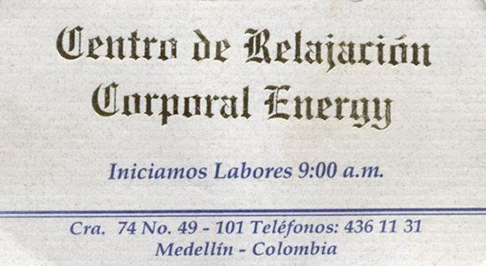
Usually about 10-20 girls to choose from. $65,000 to $70,000 for an hour full service massage.

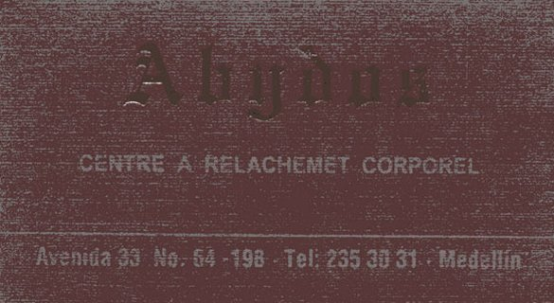
ABYDOS:
(Avenida 33 No. 64-198)
Phone: 235-3031
83,000 cop/ 1hr
Same owner as Loutron, but less expensive

LUNA LUNERA:
(Avenida 33, No. 63B-219)
One more lower-priced Casa option
http://www.lunalunera.com.co

LINDAS CHICAS
Calle 58, No. 50 A 54. Phone:
254 05 98.
Call the owner Nanci Uribe Munoz before going there.
LEJANO ORIENTE:
(Carrera 41, #18D-55)
Atras de Tempio Antonia Las Palmas, Poblado
4-266-1068, 4-311-5947
Take out fee 70k 150k-200k Overnight
I read this was the nicest Casa in Medellin, 30-40 girls to choose from.

BELLE SUITE,
CAR45 56-45,
Medellin, Colombia
Its managed by a men without smile.
The fuck room has no bed only a mattress!
30min = 30.000, 45min = 40.000, 1h 45.000
OPEN SUNDAYS

CASA BLANCA:
(Cra. 50A No. 57-3 (Balboa x La Paz)
231-6432
A lower-priced Casa option
CASA DE PIEDRA: -
Cll. 58 No. 50A-54
(business card says " Lindas Chicas", open 7 days)
From the San Antonio station take Line A north two stops to the Prado station.
Take the exit toward the front of the train (north) and the steps will lead you down into a plaza on the west side. Circle around to the right and cross under the tracks. You will see the "Bazar de los Puentes II" with a row of stores and a fruit stand. Go up the street on the left side of these stores (Calle 5 and walk about 100 feet to No. 50 A 54 with the stone front on your left.
When you get there will be a light Blue Metal door. Go in the door and you will walk three paces to a gate. Ring the buzzer and they will buzz you in the first gate and then a second one. Walk up the steps and the greeter (always male and very polite) will seat you and offer you some coffee or water from a bottled cooler (free) and/or ask if you want a soda or beer ($2,000 COP). After bringing your drinks he will ask if you want the girls presented. You can also skip the drinks altogether and just ask to see the girls.
CENTRO DE ESTETICA CORPORAL NEW LIFE:
Cl 56 (Bolivia) 43-39, entre el Palo y Giradot, 2 piso (2nd floor).
COLOMBIA - Antioquia, Medellín
Telefonos: (57)(4)2162704
$30,000 for 30 minutes. $45,000 for 45 minutes.
NEW LIFE is a Casa that is open on Sundays from 10am to 6pm.
Get there early and the selection is about 12 girls. The selection varies from week to week


BLUE ROOM:
Cl 33 78-63
COLOMBIA - Antioquia, Medellín
(57)(4)250036

CLUB MONTE CAPRINO:
Cr 50 60-47
COLOMBIA - Antioquia, Medellín
Telefonos: (57)(4)2541578

SAMSARA:
Av 33 65-09
COLOMBIA - Antioquia, Medellín
Telefonos: (57)(4)2657123
(Av. 33 No. 65-09 corner of calle 33 & calle 65)
(Yes, Av. 33 = Cll. 33 here!) From Abydos, cross Av. 33 and walk west a block.
It's located on Calle 33, one block down from Mario bros, but on the other side. It's upstairs and has a little sign that says "timbre". It opens early at around 9-10 and closes at 10pm.
ABEDUL:
Cl 57 46-12
COLOMBIA - Antioquia, Medellín
Telefonos: (57)(4)5141797
AGENCIA VIP ONLINE:
Cr 75A 10-33
COLOMBIA - Antioquia, Medellín
Telefonos: (57)(4)3530490

GEISHAS Y PUNTOCOM:
Cr 43 56-47
COLOMBIA - Antioquia, Medellín
Telefonos: (57)(4)2911182
35min = 35.000, 1h = 50.000, 2 girls 1h 85.000.
KAMASUTRA:
Cl 53 42-74 P 3
COLOMBIA - Antioquia, Medellín
Telefonos: (57)(4)2163615
http://www.kamasutramedellin.8k.com/
CASSANDRA'S:
Cra 68 #43-16
circa de La Makro
COLOMBIA - Antioquia, Medellín
Telefonos: (57)(4)4265122
.I'ts one block from the Mackro which is a big merchandise store and the only one in Medellin.
The deal with Cassandra's is that they have ST girls and LT girls. Supposedly they are open 24-7, best to call before noon. but few if any are available before 9pm. In any case, it's better to call ahead to find out who's available 70,000 cop is for about an hour in house although they really are not on the clock because there aren't any clocks in the place.
Call the owner Lilliana to ask how many girls are there and who they are or ask if a particular girl is there, if that is who you want. Lilliana actually prefers the gentlemen relax and get to know the girls first which is really different from other casas where you just meet the girls for 15 seconds then have to make a choice. You can also negotiate take out or delivery service with the girl or Lilliana for 180,000cop approx.
MIEL Y CANELA:
Cr 65 32A-43
COLOMBIA - Antioquia, Medellín
Telefonos: (57)(4)2353436
It's a bit hard to find on a big one way street with no indication of a club on the outside Once inside it's setup like a bar with couches and tables to sit relax and have a beer, while the girls are roaming the area or sitting having drinks with customers or each other. Drinks were reasonable 8000 cop for 2 beers and a water.Open from 10am to 10pm this is a lower scale massage house, but the girls are friendly and instead of just presenting, you can sit around and have a beer with them while you fondle and make your selection. The prices were 60k for an hour onsite, 70k offsite, or 250k TLN
SWEET LADY:
Cr 80 44B-287
COLOMBIA - Antioquia, Medellín
Telefonos: (57)(4)4166617
MI PIEL:
Cr 66Aa 34-61
COLOMBIA - Antioquia, Medellín
Telefonos: (57)(4)2655369
CENTRO DE ESTETICA BOLIVIA:
Cl 56 41-54
COLOMBIA - Antioquia, Medellín
Telefonos: (57)(4)2920661
CENTRO DE MASAJES PEKÍN:
Cl 10A 43A-31 Apto 201
COLOMBIA - Antioquia, Medellín
Telefonos: (57)(4)2686422
SALA DE MASAJES ROSTROS:
Cl 43 68A-23
COLOMBIA - Antioquia, Medellín
Telefonos: (57)(4)2304885
TRATAMIENTOS TERAPEUTICOS MARIA:
Cr 48 10-45 L- 239
COLOMBIA - Antioquia, Medellín
Telefonos: (57)(4)2685130
OSORIO MARINO:
Cr 58D 24A-13 Bello
COLOMBIA - Antioquia, Medellín
Telefonos: (57)(4)4629424
AFRODITA'S:
Cr 43 56-49
COLOMBIA - Antioquia, Medellín
Telefonos: (57)(4)2544810
30min = 30.000, 1 hours 40.000, 1 hour 2 girls 50.000
The foyer is decorated with some bamboo poles to give the illusion of a Zen garden!
SALA DE MASAJES DALLY:
Cr 45 50-59
COLOMBIA - Antioquia, Medellín
Telefonos: (57)(4)5124613
TERAPIAS ANTIESTRES JIN SHIN DO:
Cr 48 10-45 L- 126
COLOMBIA - Antioquia, Medellín
Telefonos: (57)(4)2684784
MASAJE JAPONÉS:
Cr 49 57-51 L- 222
COLOMBIA - Antioquia, Medellín
Telefonos: (57)(4)2515158
REIKI REFLEXOLOGIA Y MASAJE TERAPEUTICO:
Cl 41 33A-48
COLOMBIA - Antioquia, Medellín
Telefonos: (57)(4)2390750
ESCUELA DE MASAJES CASA DE MASOTERAPIA:
Cl 37 Sur 43-55 P 2 L-201 Envigado
COLOMBIA - Antioquia, Medellín
Telefonos: (57)(4)3327696
MASAJES CORPORALES MARIA O:
Cl 2 53-65
COLOMBIA - Antioquia, Medellín
Telefonos: (57)(4)2553197
AIFFE:
Cr 45 58-11 Apto 1
COLOMBIA - Antioquia, Medellín
Telefonos: (57)(4)2546201

ATENEA SALA DE MASSAJES:
Cra.47 Sucre No45 -42 First Floor
10;30 to 7;30
Telefonos 511-3976
OPEN SUNDAYS

ALEJAS SALA MASSAGES:
Calle54 N* 42-13,
tel 216 -9602

BARCELONA SALA DE MASSAJES:
calle 59 N* 50-12 Prado Centro,
tel 254-2994,
open sundays.

STRIP CLUBS
Places like Faces Dos, La Isla and Show SanDiego have also been widely reported. You enter, sometimes paying a cover, sometimes not, find a table, watch the strippers (and some do not actually strip), look around and see if you like anything in the place, call them over for a drink and if you like them begin negotiations. Most have on site ST rooms. There is a take out fee as these girls actually work for the clubs.

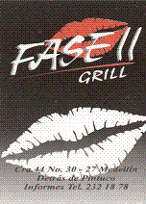
FASE II:
(CRA. 44 # 30-27)
phone 232-1878
For a night time place, this strip club is one of your best bets.
It's $10,000 to get in, but they have the nicest rooms of all the night time places.
The girls may not look as good as La Isla, but their attitudes are much better.
$150,000 for an hour in the room with a girl. 150.000cop bar fine to take girl out.

TORRE SHOW:
A medium/low level strip club run by the same owner as San Diego Show and La Isla.
Cra 74 Ni 49 - 127
Tel: 230 6945
5,000 pesos entrance
It is now almost right next to Energy, at the end of the block, upstairs.
Was not too impressed, in fact least fav of all the strip joint I went to.
A medium/low level strip club run by the same owner as San Diego Show and La Isla.
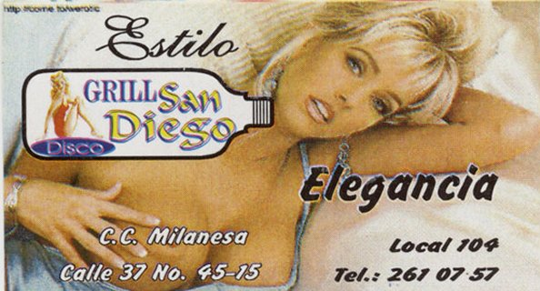
Drinks are more reasonable than the other clubs and the girls will only run you $62,000 for about 45min.
Their sister club San Diego isn't a bad bet either.
APOTEOSIS CLUB:
(Cll 44 No 74-70) in San Juan
Nude Club, Table Dances, Female Dancers, Full Bar
It has a big stripper stage in the middle with something they called "The Erotic Shower" right in the middle.
$70,000 pesos for an hour, about $35 bucks.
It is in a warehouse area of town with not many businesses on either side. Inside it is nicely appointed,

DISCO GRILL SAN DEIGO:
C.C. Milanesa Local 104,
(Calle 37 No. 45-15)
Tel. 262-9978

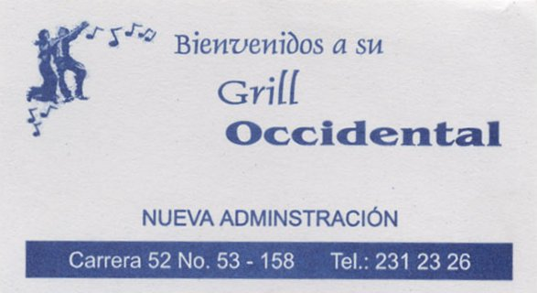

GRILL OCCIDENTAL:
(Carrerra 52 No. 53 - 158)(Central area)
Phone: 231-2326

APOTEOSIS CLUB:
(Cll 44 No 74-70) in San Juan
Nude Club, Table Dances, Female Dancers, Full Bar
It has a big stripper stage in the middle with something they called "The Erotic Shower" right in the middle.
$70,000 pesos for an hour, about $35 bucks.
It is in a warehouse area of town with not many businesses on either side.
Inside it is nicely appointed,
CANTANGA DISCO CLUB:
(Cll 50 No 67 - 45)
Nude Club, Stage Dances, 30 Female Dancer, Full Bar, Drinks: $15
Tel. 230 07 37
ENCUENTROS CLUB:
(Cll 50 No 68 89)
Nude Club, Stage Dances, Female Dancers, Full Bar, Drinks: $4
Tel. 230 50 14
LICORES Y CONPANIA:
(Cra 74 No 42 - 97 Estadio)
Nude Club, Stage Dances, 18 Female Dancers, Full Bar, Drinks: $10
Tel. 230-65 68
NEMISIS CLUB:
(Cll 44 78 -90)
Nude Club, Table Dances, Female Dancers, Full Bar, Drinks: $15

PEGASOS CLUB:
(Clle 44 No 80-15)
Nude Club, Stage Dances, Female Dancers, Full Bar, Drinks: $6
RINCON LEO:
(Clle 50 No 68-53)
Nude Club, Stage Dances, Female Dancers, Full Bar
BAR METROPOL:
(Calle 47 No 45-11)
Tel. 251-5699
STREET GIRLS (see Medellin SG guide at bottom)
CALLE 33:
Calle 33 SG's, which is around the corner from Club San Diego, start to congregate after 9 pm.
They usually ask for 40,000 pesos for one session If your Spanish is pretty good, you probably can get it for 30K? When alone have a cabbie drive real slow around San Diego & Fase II. Have the girls come to you while your in the cab it's much safer.
CALLE 53 & AVENIDA DEGRIEF:
The SW Zone on Calle 53 Is also known As Ave. De Greif.
Also That is where The Red Light Zone is where all the girls come and go out of the clubs. It is on the corner, with the Bar El Faro on one side of the street and the Hotel Raudal on the other. Ask the Cabbie to keep going down
Calle 53 for 2 more blocks and let you off at Avenida De Grief, right in front of the El Faro Bar.
There are about 4 short time hotels here. They are typical TJ style skank city hotels. It is a bit dangerous and seedy. Most of the chicas seemed to work out of Hotel Luna Azul.
The Calle 53 babes were dirt cheap.. You can get away with never paying more than $20,000 which is 8.50. Extra services will cost you more.

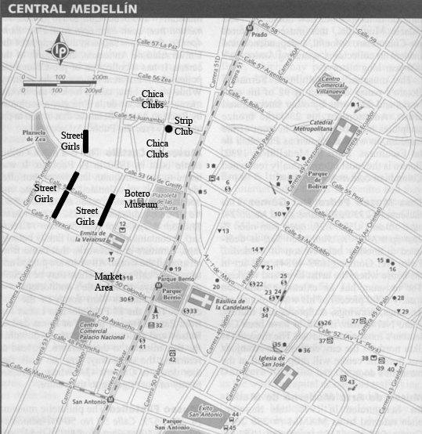

MAYORISTA AREA:
(named for a huge street market next door) Near Hotel El Castillo.
Mayorista, is a street, a few blocks behind Mangos, Mayorista, located in the suburb of Itagui.
There are two blocks of hotels and bars, where the chicas stand on the sidewalk TJ style, shoulder to shoulder.
It is a must see. After about 10pm to 2am the chicas lineup.
Sometimes 50 to 100 chicas can be found here, busiest on Friday and
Saturday nights.
They want 20K (about 9 bucks) for half an hour, plus a hotel fee of about the same. I FOUND KAREM A BEAUTIFUL 19YR OLD SPINNER HERE FOR 100,000COP FOR all night (Todas Noches)
Try Street girls in the city center where there were a ton of girls on the streets near the Museum Botero.
They are behind the museum one or two streets and are either side of the main street that runs next to the Museum.
Be careful here. Remember this is the area that the taxi drivers warn about. 15K ($6 USD at the time) to do the deed.
SHORT TIME/LOVE HOTELS
HOTEL EROS:
Cr 54 53-91
COLOMBIA - Antioquia, Medellín
(57)(4)5126220
http://www.guiacereza.com/eros/
It is within walking distance of the street girl areas around Museum Plaza Botero.
It is right down the street from the El Faro Bar, one of the prime street girl areas.
It costs $31,000 for three hours (about 14 bucks) and $41,000 for 12 hours (about 20 bucks).
During the week they charge $31,000 ($13.29) for three hours and $35,000 ($15 bucks) for 12 hours.
They will charge a bit more for an extra chica, it’s a really nice room with a jacuzzi for a little fun on the side.
There is also a mini fridge that allowed the girls to have something to drink.
There is an excercise machine in the room, but it is not for excersizing.
It is for you to get your chica on the device for unusual sexual positions and pound away.
Wow...they thought of everything. The chicas refer to THIS hotel as the Hotel Elegante.

MOTEL SOL Y LUNA
Vía La Estrella entrada principal.
Cra. 55 No 80 sur - 106.
2790022
http://www.motelsolyluna.com

MOTEL ARIES
Vía La Estrella.
Cra. 50 n. 79- c Sur 43.
2790844
http://www.guiacereza.com/cupido/
MOTEL LOS CONCHES:
Cl 71 # 51-60
COLOMBIA - Antioquia, Medellín
Telefonos: (57)(4)2121510
Fax: (57)(4)2121720
http://www.motelloscoches.com/home.htm
MOTEL LOS CHALETS:
Cl 80Sur # 55-71 La Estrella
COLOMBIA - Antioquia, Medellín
(57)(4)2791449
http://www.loschalets.com/
MOTEL LOS COLORES:
Cra. 51 #72 A-13
2119046 - 2115252
http://www.guiacereza.com/loscolores/

MOTEL LOS DOS
Entrada p.pal a La Estrella, a 600 mts. del desvío.
Cra. 55 N.80 Sur 206.
2791900
http://www.guiacereza.com/losdos/

MOTEL CUPIDO
Calle 46 n. 43-17.
2392180.
http://www.guiacereza.com/cupido/

MOTEL MOTIVOS:
Cl 80Sur # 50-123 La Estrella
COLOMBIA - Antioquia, Medellín
(57)(4)2794000, (57)(4)2793553
http://www.motivos.com.co/

MOTEL UNICORNIO
Autopista Sur (South freeway) vía La Estrella.
Calle 79 sur n. 49-150 La Estrella.
3095050 - 3095033.
http://www.guiacereza.com/unicornio/

MOTEL CIUDADELA DORESKY
Vía Machado - Copacabana.
Calle 46 #78-179.
481 0052

MOTEL SIESTA
KM 1 vía San Cristóbal.
Cra. 91 # 64E - 50.
2642464
http://www.guiacereza.com/siesta/

ECLIPSE MOTEL:
Dg 53 14-04 Bello
COLOMBIA - Antioquia, Medellín
(57)(4)2749434

EL CRUCERO DEL AMOR:
Guarne
COLOMBIA - Antioquia, Medellín
(57)(4)5301080
http://www.guiacereza.com/crucerodelamor/

MOTEL EL DESCANSO DEL AMOR
autopista Medellín – Bogotá km. 4.
4810600.
http://www.guiacereza.com/descansodelamor/
EL REMANSO MOTEL (EL REMANSO ):
Cl 61 50C-59
COLOMBIA - Antioquia, Medellín
(57)(4)2544814
ESTADERO MOTEL CANDO (ESTADERO CANDÓ ):
Copacabana
COLOMBIA - Antioquia, Medellín
(57)(4)2740261
HOSTAL 71-50:
Cr 65 71-50
COLOMBIA - Antioquia, Medellín
(57)(4)4414929, (57)(4)2578011
HOSTAL BRISAS DEL ESTADIO:
Cl 51 67B-125
COLOMBIA - Antioquia, Medellín
(57)(4)2303424
HOSTAL PORTON DEL ESTADIO (HOSTAL PORTÓN DEL ESTADIO ):
Cl 50 68-37
COLOMBIA - Antioquia, Medellín
(57)(4)2303014
HOSTAL SOUTH BEACH:
Cr 44 30-09
COLOMBIA - Antioquia, Medellín
(57)(4)2324784
HOTEL COLLINS:
Cl 50 67-102
COLOMBIA - Antioquia, Medellín
(57)(4)2301510
HOTEL EXOTICO (HOTEL EXÓTICO):
Cl 56 52-65
COLOMBIA - Antioquia, Medellín
(57)(4)5125619
HOTEL LINES LTDA.:
Cl 56 52-15
COLOMBIA - Antioquia, Medellín
(57)(4)5130759
HOTEL LUCCA:
Cr 54 54-60
COLOMBIA - Antioquia, Medellín
(57)(4)2511859
HOTEL NUEVO MILENIO:
Cr 47 58-43
COLOMBIA - Antioquia, Medellín
(57)(4)2924317
HOTEL PUNTO CERO:
(Diagonal 64E No.67-435)
Dg 64E 67-345
COLOMBIA - Antioquia, Medellín
(57)(4)4376437
Very Clean and the price for six hours (3 people) was 55,000CP.roughly $23.60US.
It has all the Goodies/Toys a "Monger" would want.
The Telephone # are: 437 6437 / 437 4552 / 257 1443 & 437 7028.
All of the cab drivers know where it is.
LAS CABANAS:
14 No. 43F - 65 El Poblado
Habitación $ 46.000

LA SUITE MOTEL
Cra 55 N. 87 Sur-71.
279 44 44.
http://www.suitemotel.com.co/

HOTEL PENTHOUSE:
Hotel Penhouse Calle:
63 No. 115 -051 San Cristobal
Habitación desde $ 48.000
HOTEL LUNA AZUL:
The Hotel Luna Azul has street girls standing in the doorway all the time. I usually saw 4-5 girls right at the doorway. The problem here is that there is also a walkway you have to walk down to get to that door,and there are usually 6 to 12 Chicos sitting there on the sidewalk. You have to walk the gauntlet with your selection, and these guys eye HER up and down as she walks by.
HOTEL MORGAN:

HOTEL FANTASIA
Diagonal al Museo de Antioquia.
Cra 52. #53-58.
2511438 – 2512980
http://www.guiacereza.com/hotelfantasia/

HOTEL LUCCA
Cúcuta con Juanambú.
Cra. 54 No. 54-60.
2511859
http://www.guiacereza.com/luccahotel/

HOTEL NUEVO MILENIO
Sucre enter la Oriental y Cuba.
Cra. 47 N. 58-43.
2924317
http://www.guiacereza.com/nuevomilenio/

HIGH CLASS ESCORTS
If you are looking for this type of girl I would recommend calling Juan. He has a prepago agency with very nice girls ranging in price from about 150,000 pesos all the way up to the millions of pesos for models and tv personalities.
Give him a call and tell him what you like and he can get it for you.
311-309-3960.
http://www.e-extasis.com/medellin.htm
http://www.lafeemme.com/medellin.htm
http://www.modelosprepago.com/
http://www.lasprepagos.com/

CONTACTOS:
Cr 78 # 35-98 Of 201
COLOMBIA - Antioquia, Medellín
Telefonos: (57)(4)4161677
http://www.contactosteune.com

MONGERING HOTELS
MEDELLIN MANSION:
Fantastic place very, supportive of mongering, girl friendly, no charge for guests, excellent staff extremely helpful, great place for the newbie to start out. Heated pool & Jacuzzi in some rooms, breakfast, has mongering parties and invites lots of very hot chicks for your pleasure.
http://www.medellinmansion.com
EL CASTILLO:
Sister house to the Mansion.
http://www.medellinapartments.com
CLUB VIP:
http://www.clubvipmedellin.com
http://www.medellinvacationapartments.com/index.html

